**Lab 01: Environment Setup and Java Basics**

Lê Quốc Tuấn 20236008

Ex 2.2.5:

Write a program to calculate sum, difference, product, and quotient of 2 double numbers which are entered by users.

Code:

Exercise 2.2.6

1.The first-degree equation (linear equation) with one variable

Code:

2. The system of first-degree equations (linear system) with two variables

Result:

Ex 6.1

Write, compile and run the ChoosingOption program

Code: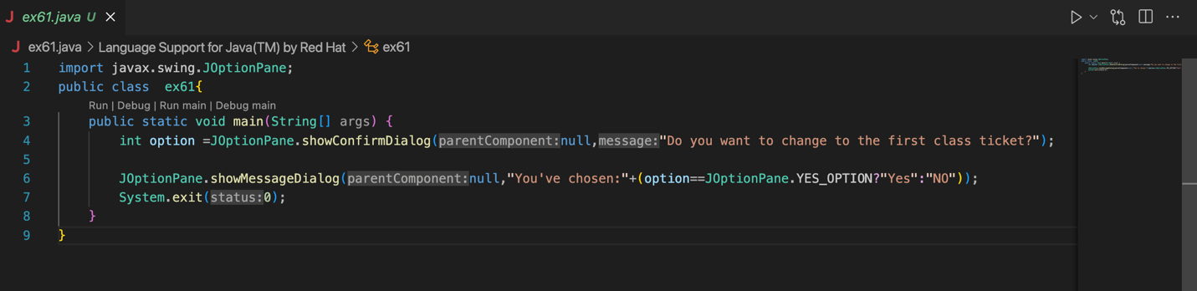

Result:

_ If choose YES:

_ If choose NO or CANCEL:

1.

When the user selects "Cancel". The variable option will be assigned the value JOptionPane.CANCEL_OPTION.

The program only checks that the user has a "Yes" option, but the other fields are valid

default value is "No"

So the user chooses "Cancel" rather than "No".

2.

Switch to using showConfirmDialog to force the user to select only "Yes" or "No"

int options = JOptionPane.showConfirmDialog(null, "Yes", "No", JOptionPane.YES_NO_OPTION);

Ex 6.2

Write a program for input/output from keyboard

Code: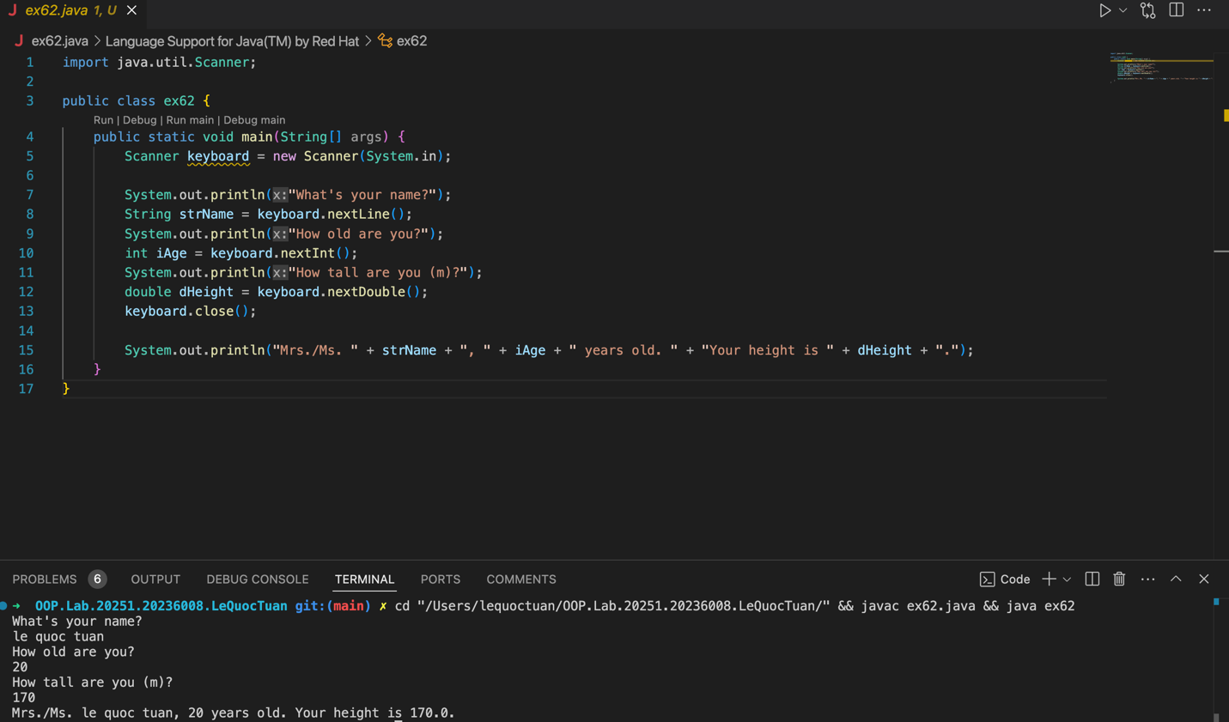

Ex 6.3

Write a program to display a triangle with a height of n stars (*), n is entered by users.

Code:

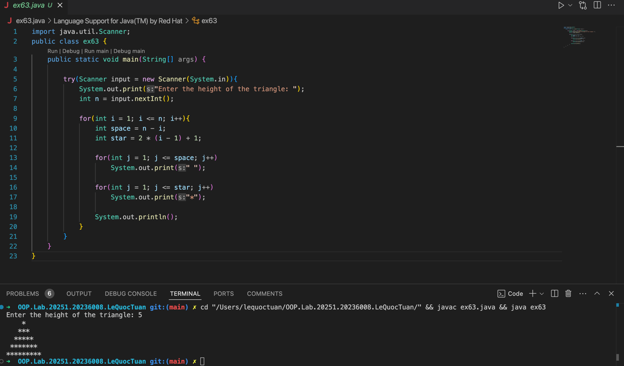

Ex 6.4

Write a program to display the number of days of a month, which is entered by users (both month and year). If it is an invalid month/year, ask the user to enter again.

Bài 6.5

Write a Java program to sort a numeric array, and calculate the sum and average value of array elements.

Code:

Bài 6.6

Write a Java program to add two matrices of the same size.

Code:

